**SUPER STORE SALES ANALYSIS**



**ABOUT**

Sales analysis is using data to evaluate sales team performance. It provides valuable insights about the top performing and underperforming products/services, selling and market opportunities, and includes [sales forecasting](https://blog.close.com/sales-forecasting-strategies/). Regular sales data analysis provides an understanding of the products that your customers are buying and helps you dissect why they are behaving in a certain way. You can also find patterns in your lead conversions and drop offs. All of these aspects enable you to optimize your [sales process](https://blog.close.com/how-to-build-a-sales-process-that-gets-results/).

**DATASET**

The dataset is taken from Kaggle and it contains the general details of the purchases that have occurred in the store.

**DATA VISUALIZATION**

Data visualization is the representation of data through use of common graphics, such as charts, plots, infographics, and even animations. These visual displays of information communicate complex data relationships and data-driven insights in a way that is easy to understand.

Data visualization is the graphical representation of information and data. By using v[isual elements like charts, graphs, and maps](https://www.tableau.com/data-insights/reference-library/visual-analytics), data visualization tools provide an accessible way to see and understand trends, outliers, and patterns in data. Additionally, it provides an excellent way for employees or business owners to present data to non-technical audiences without confusion.

In the world of Big Data, data visualization tools and technologies are essential to analyse massive amounts of information and make data-driven decisions.

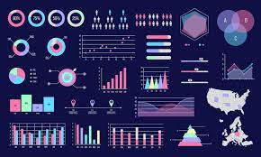

**IMPLEMENTATION**

Questions answered in this analysis are:

1. Which are the most selling products?

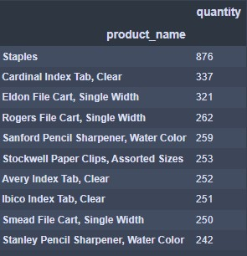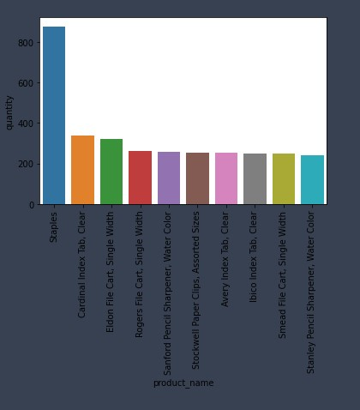

1. Which are the Top 10 products by sales?

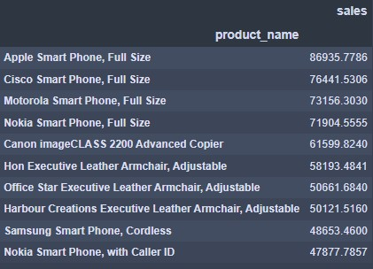

1. Which are the most profitable products?

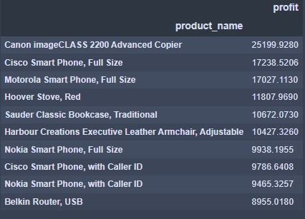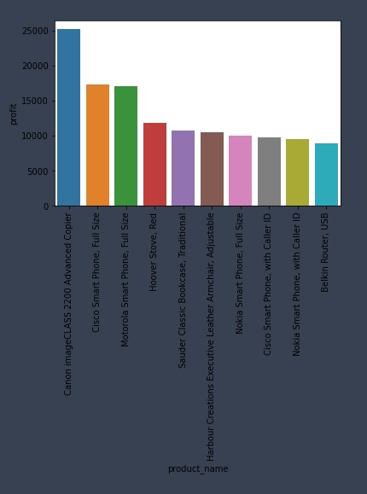

1. What category sold the most?

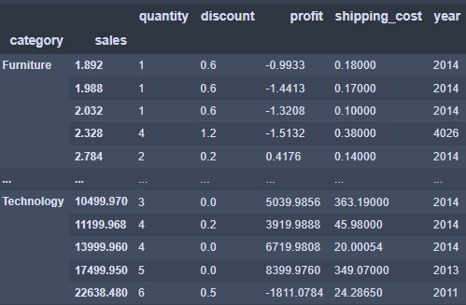

1. Which is the most profitable category?

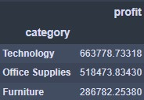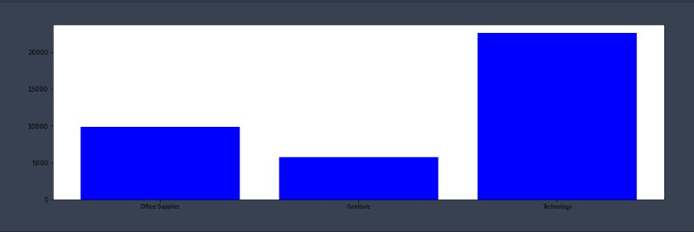

1. Total sales values by category and subcategory

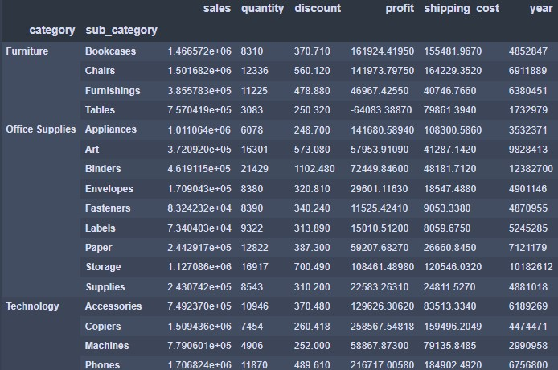

1. Which are the most selling products in subcategory?

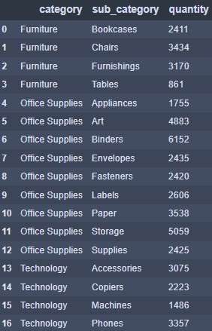

1. Which customer segments are the most profitable?

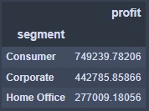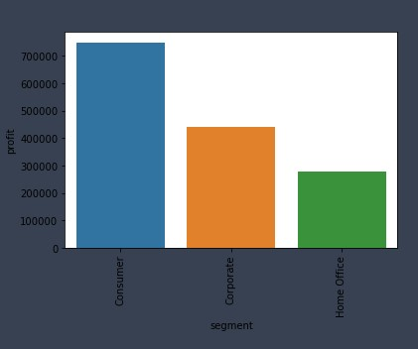

1. What shipping modes sold the most products?

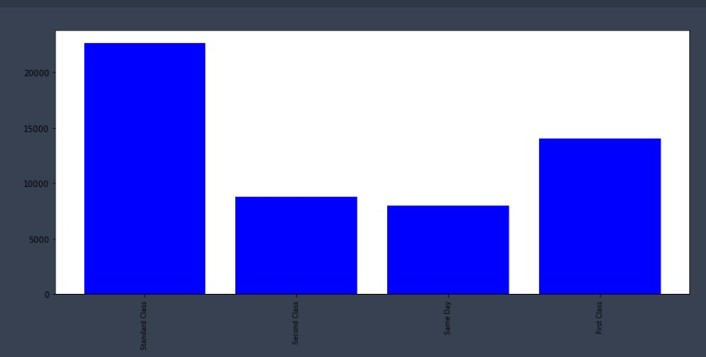

1. Visualize the 'Category' column from the Shipmode column dataset standpoints.

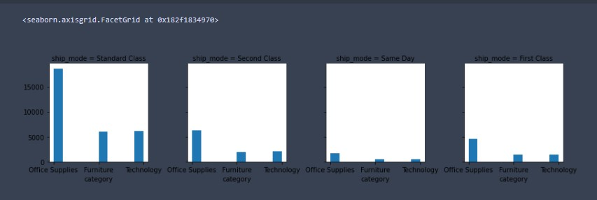

1. What market sold the most products?

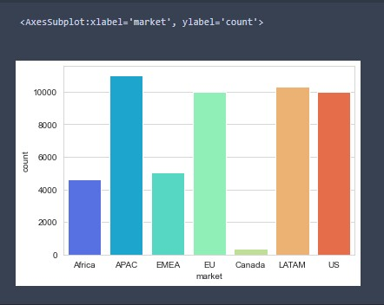

1. Which are the Top 10 country by sales?

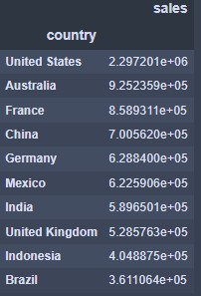

1. Which is the average shipping cost for top 10 different countries?

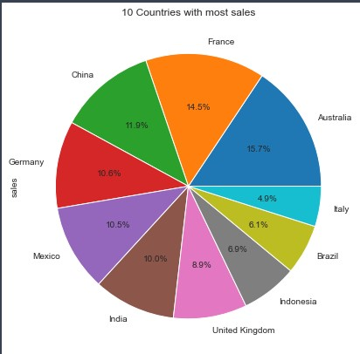

**SUMMARY**

Using the visualizations, we can conclude the questions on analysis related to sales. It helps the store take business decisions for better profit.

